**Energy Efficient IoT Virtualization Framework with Peer to Peer Networking and Processing**

In this project author describing concept to minimize energy consumption and maximize task request process in IoT Virtualization Framework. IoT/Peer (examples CCTV camera, mobile phones or body sensors which sense data and the send to centralized server using Internet Connection) means small devices which are connected to internet and exchange data with cloud/servers using that internet connections. This small IoT devices will run on battery and if execute heavy logic then they will lose battery faster and to prevent that IoT devices will offload task to VM/Relay/Edge Servers. VM/Relay node runs on cloud with high resources and they accept request from IoT devices and execute request and send response back to IoT devices.

In this paper author is evaluating performance of all 3 techniques used in this IoT framework.

1. Relay Only: All task IoT devices will send to relay only for execution and in this technique 80% task execution will be successful and 8% energy saving also can be observe. As all task run by Relay only so IoT devices can saved much energy.
2. Object Only: In this technique all task will be executed by IoT device only and this device will have less resources and execution time will be more due to this reason task execution will be less (up to 20% only) and energy saving will be more as its not sending/ receiving data from Relay nodes via network. But this technique execute less tasks.
3. Hybrid Technique: In this technique some process will be execute by IoT and other task will be executed by Relay/VM’s. This technique energy consumption will be high as its taking energy from IoT and relay nodes. Task execution is similar to first technique Relay only. So in all techniques Relay only is giving better performance.

To implement Relay only technique first we will calculate all closer VM/Relay node, from all closer VM/Relay will choose only that VM/Relay which is free. Closer VM will take less execution time and energy consumption.

In this project as task we are uploading image and then sending to relay node to resize image. While sending will look for closer VM by calculating distance between source IOT device and all VM’s.

Module Information

VM module: This will act like a VM server and run in infinite loop and wait for request from IoT devices, upon receiving request this VM will resize image based on given width and height and then send resized image back to IOT devices.

Simulation Module: This module act like a simulation where number of IoT devices will be displayed and upon uploading image it will look for nearest and free VM and then offload task to that VM for execution.

Screen shots

This projects contains two folder 1) VM 2) Simulation

First double click on ‘run.bat’ file from ‘VM’ folder to get below screen and let it run

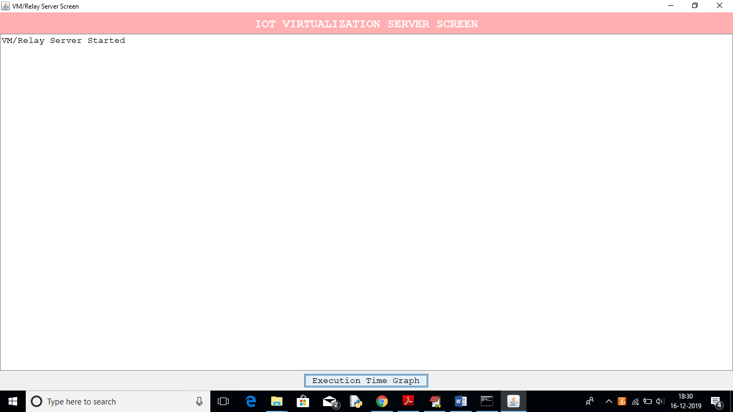

Now double click on ‘run.bat’ file from ‘Simulation’ folder to get below screen

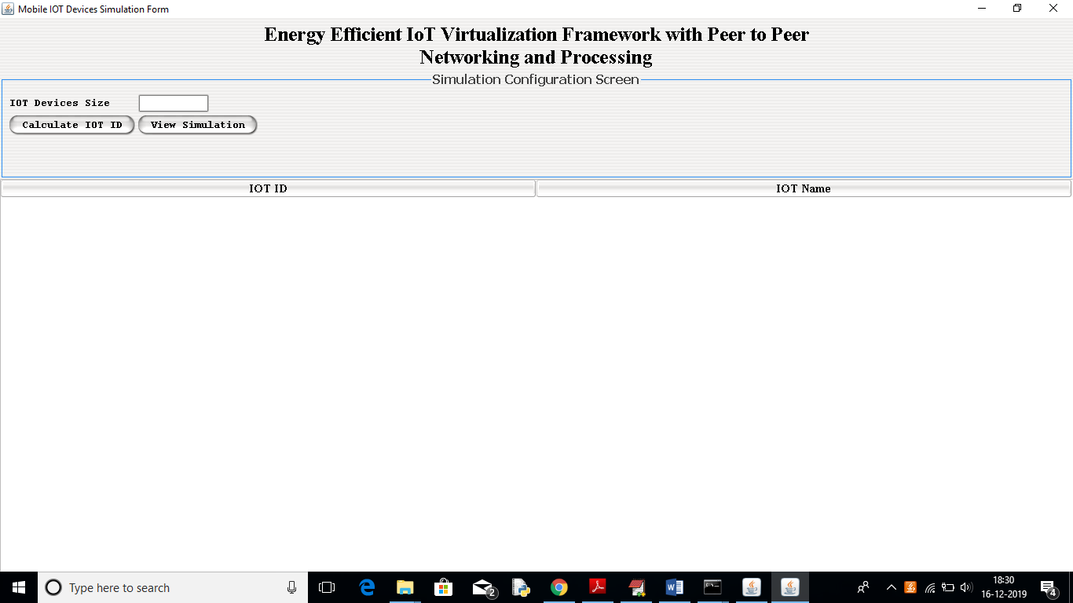

In above screen enter IOT Devices Size and then click on ‘Calculate IOT ID’ button to assign ID to each IOT device

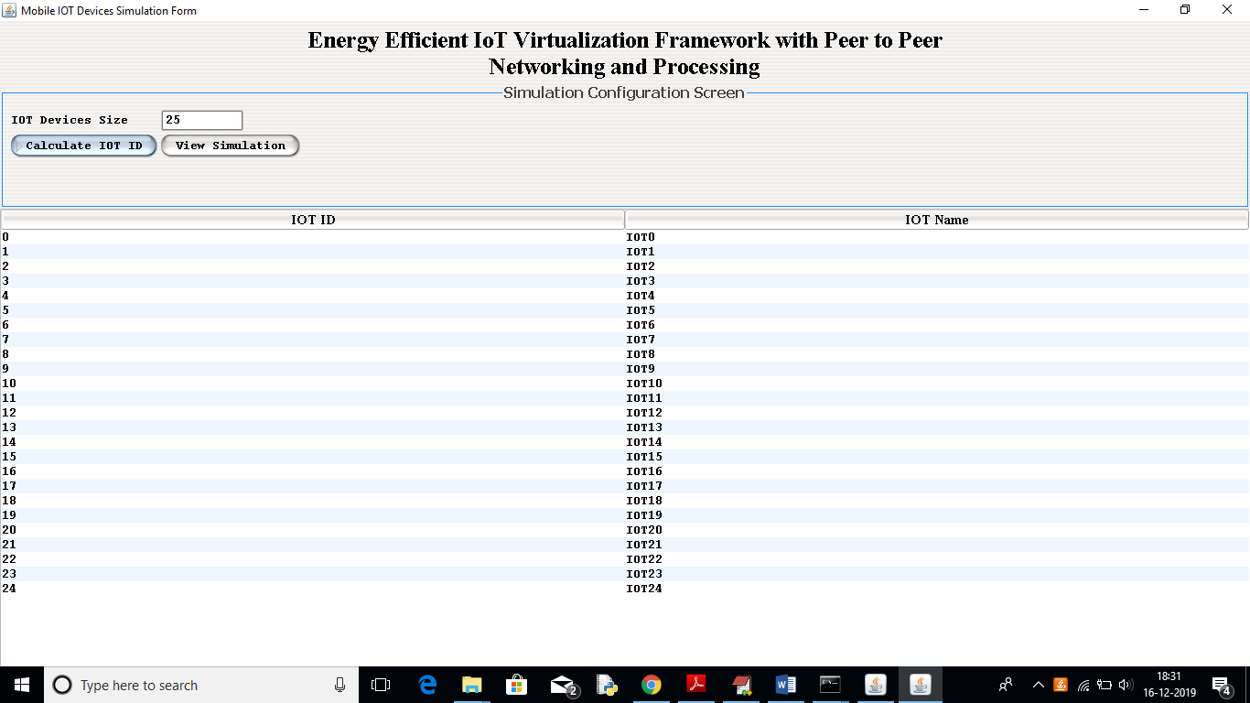

In above screen I entered IOT Device Size as ‘25’ and then click on ‘Calculate IOT ID’ button to assign ID to each device. Now click on ‘View Simulation’ button to get below screen

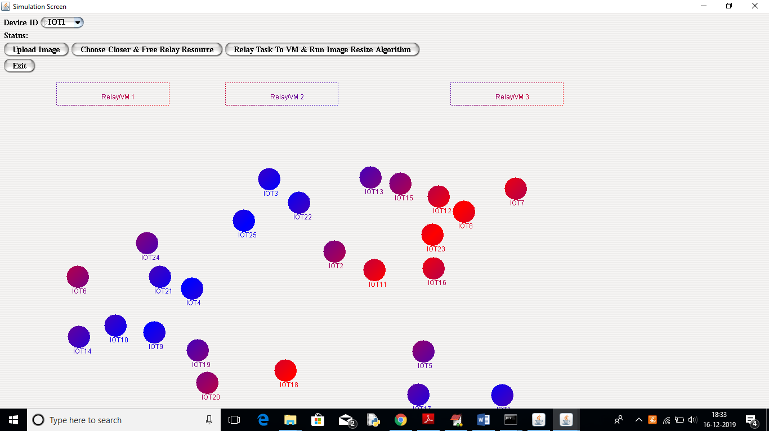

In above screen each circle represents as one IoT device and we need to select any device ID from top drop down box and then click on “Upload Image” button to upload image and then this image will send to VM server to resize it.

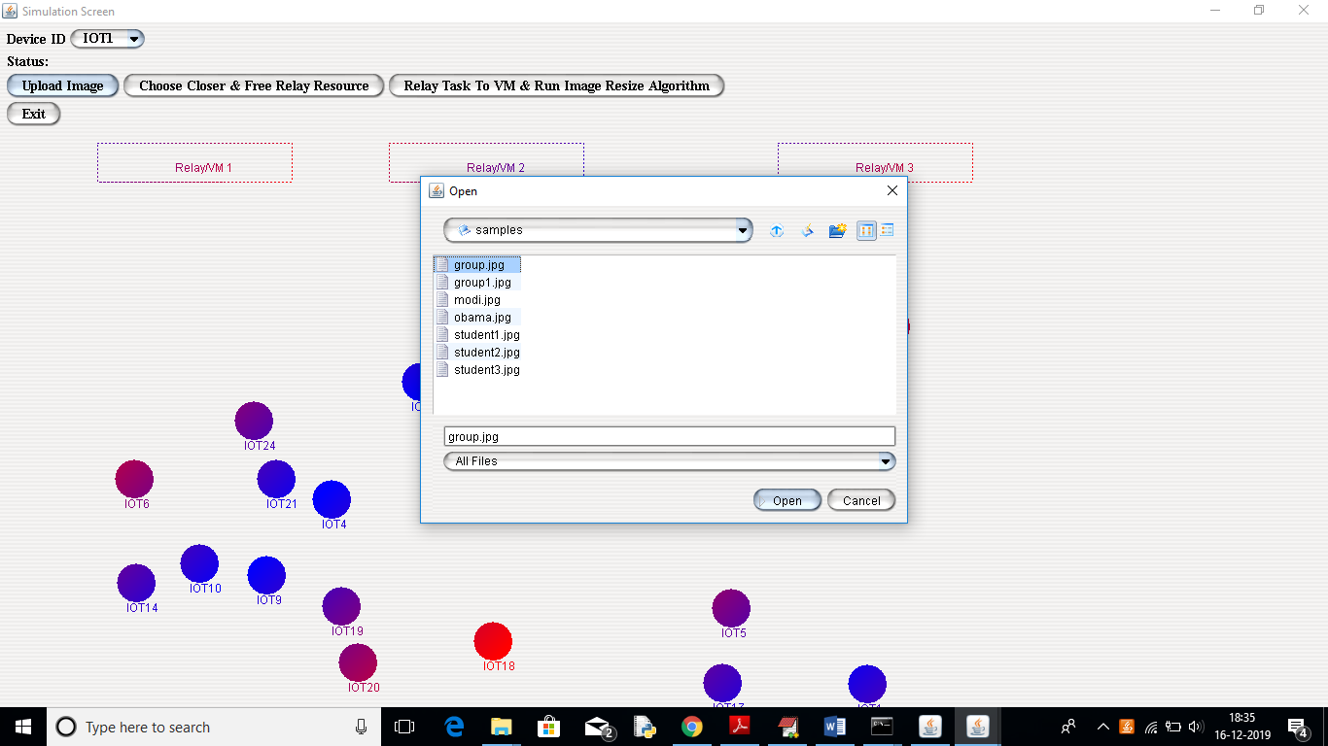

In above screen I selected one image and then click on ‘Open’ button to load it. After loading image click on ‘Choose Closer & Free Relay Resource’ button to find free and closer Relay/VM.

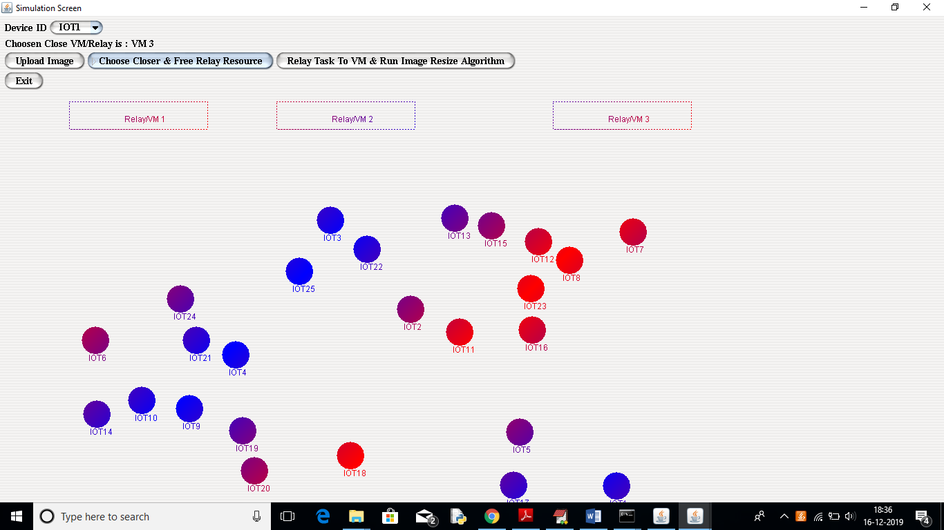

In above screen below Device ID we can see for selected IOT1 device closer VM is VM 3. Now click on ‘Relay Task to VM & Run Image Resize Algorithm’ button to enter new image height and width and then send that task to VM

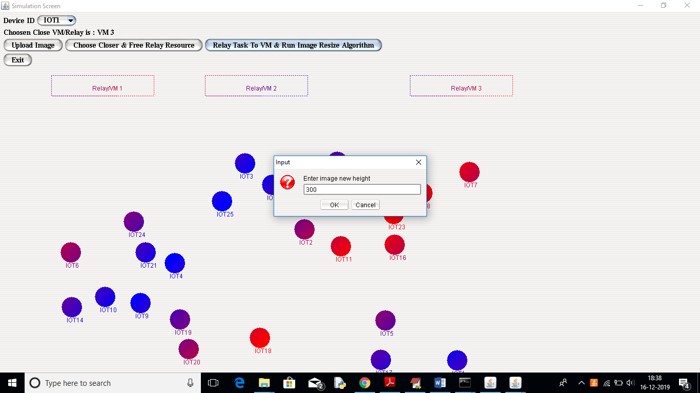

In above screen entering image new height and width as 300 and 300. Now click ‘OK’ to offload task

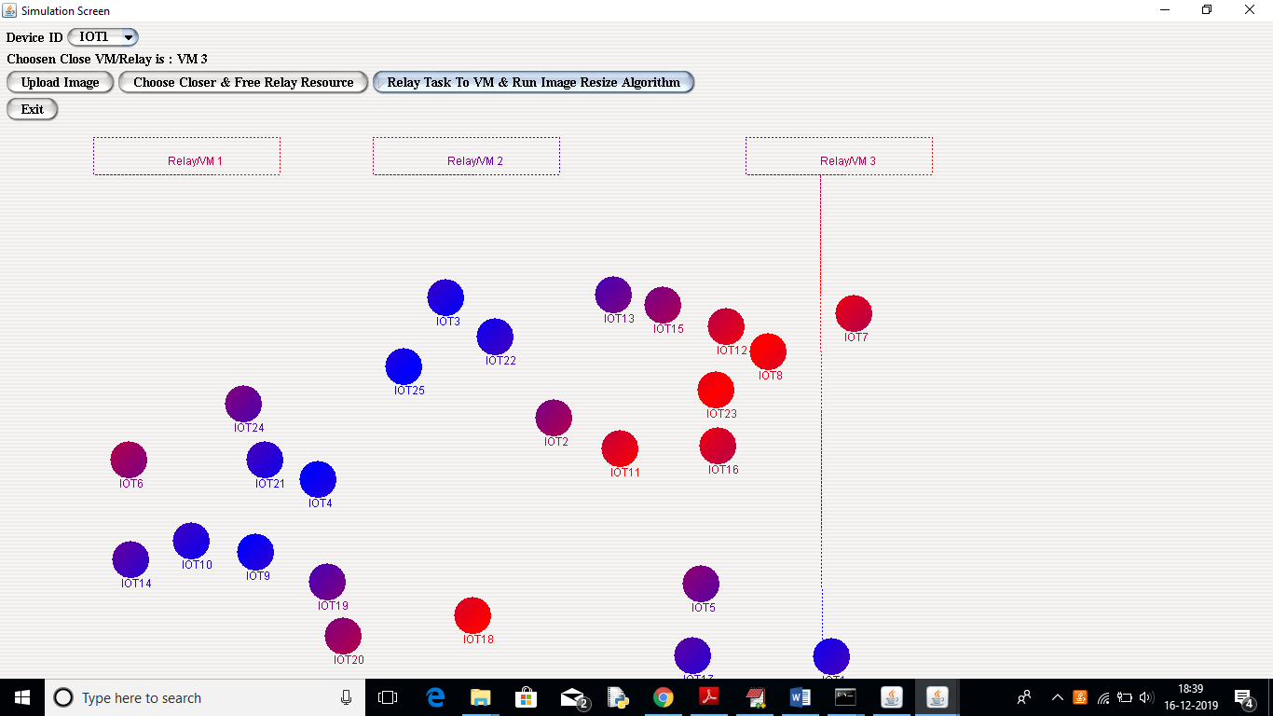

In above screen a line between IOT device and VM server indicates data is transferring between them and we get new resize image in below screen

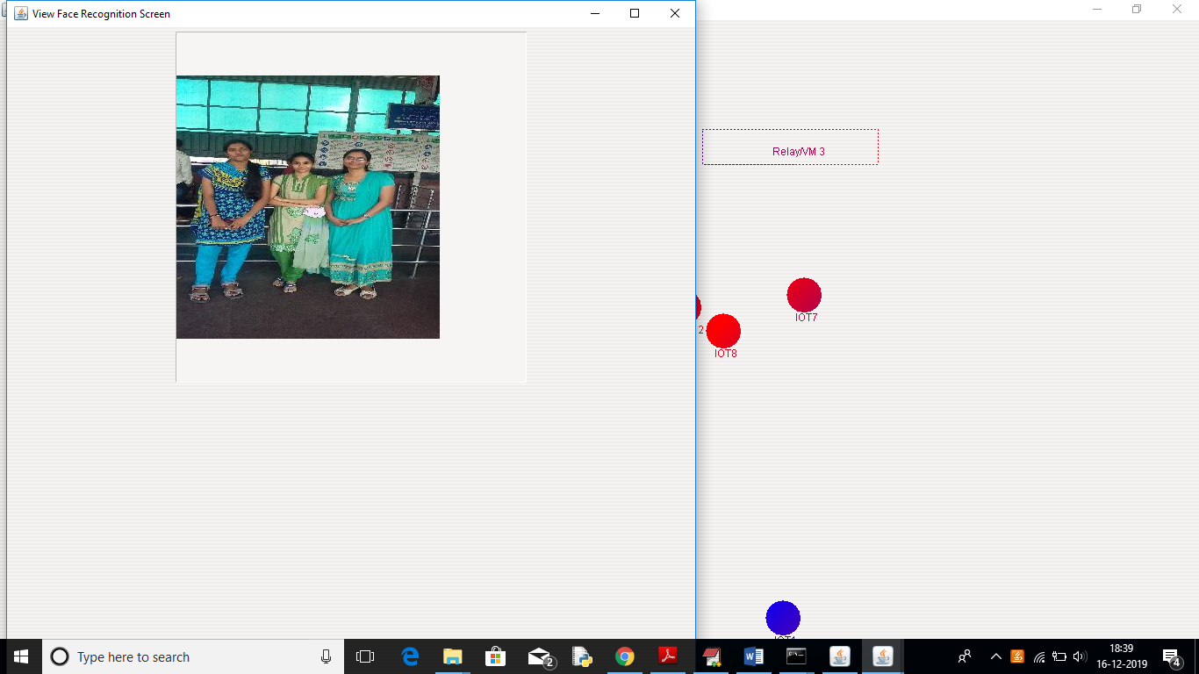

Similarly you can select any IOT device and then upload image and resize to any size and test. Now we can see execution time graph at ‘VM’ screen below

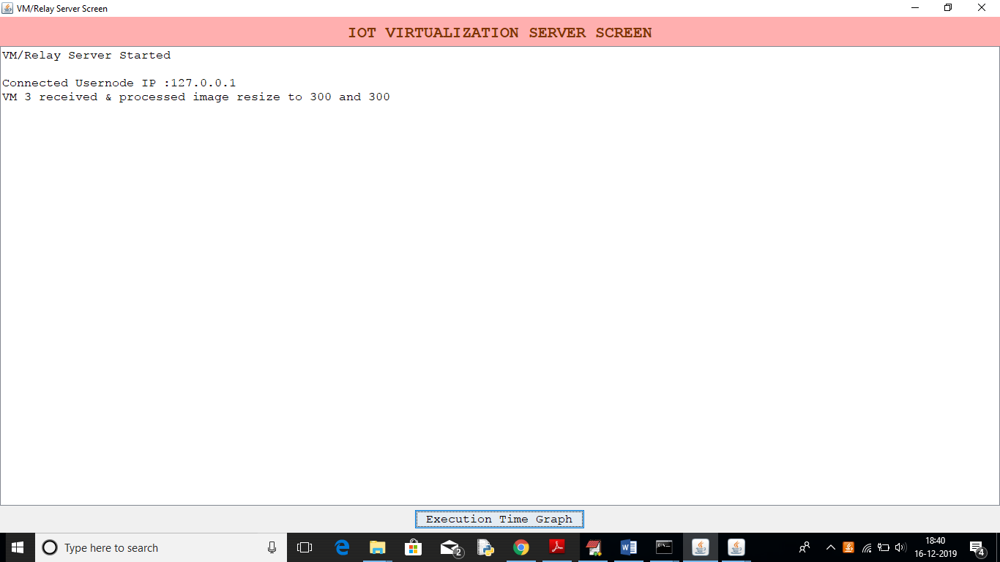

In above screen we can see message that VM 3 received request to resize image for 300 and 300. Now click on ‘Execution Time Graph’ button in above screen to get below graph

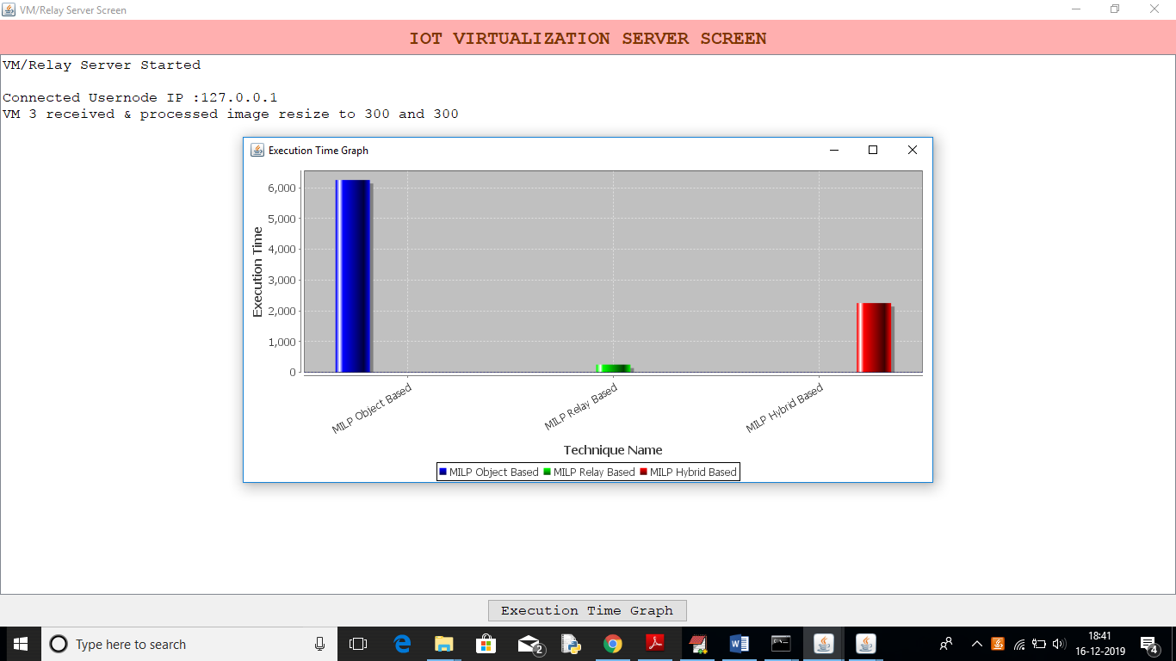

In above graph x-axis represents technique name and y-axis represents execution time and we can see MILP Relay technique took less execution time and its energy consumption will be less